**UNIVERSITY OF ECONOMICS HO CHI MINH CITY**

**VINH LONG CAMPUS**

**FINAL REPORT**

**SCIENTIFIC RESEARCH TOPICS FOR STUDENTS IN 2024**

**INTEGRATE ONLINE SUPPORT SERVICES AND CHATBOTS TO INCREASE CUSTOMER EXPERIENCE**

Belongs to the field of scientific majors: Information Technology

Instructor: Lê Hoàng Son

Implementation group:

Research group leader: Trần Thị Thùy Trang

Member 1: Phạm Nguyễn Tấn Phát

Member 2: Nguyễn Thị Huỳnh Như

Member 3: Nguyễn Chí Khanh

**Vinh Long, 2024**

**Instructor's opinion** **Image category**

**List of terms and abbreviations**

**CHAPTER 1: OVERVIEW**

## Reason for choosing the topic

In the modern era of technology, chatbot is the next big thing in the domain of conversational services. A chatbot is a virtual person who can effectively talk to any human being using interactive textual as well as verbal skills. There are many statistics available which suggest that integration of chatbot in any business as a part of their customer service increases the business progress and customer satisfaction exponentially.

Under the impact and continuous and rapid development of the Internet, information on the network environment becomes increasingly rich. Science and technology are also increasingly developing to new heights. Many online business companies are increasingly expanding, research into creating a Chatbots system is one of the developing technologies that deserves attention. When building a Chatbots system, it helps customers make the right decisions, thereby increasing customer experience when making purchases as well as increasing the ability to reach new customers and increase revenue for customers. enterprise.

* 1. **Research objectives.**

In this report, the main goal of the topic is to learn about Chatbots systems and Chatbots applications that suit the needs of businesses. Specifically, through building a Chatbots system based on the Dialogflow platform and Python language. Establish the idea of an interaction model between humans and machines through the Chatbots system. The system can be put into application, with the goal of assisting with customer consultation, helping customers answer questions, increasing customer experience, increasing excitement as well as experiencing the service in the best way. when using the system.

* 1. **Research methods.**

Methods of using tools such as support libraries for Chatbots such as: Dialogflow,...

Use programming languages to build algorithms.

Empirical Method: Chatbots use multiple systems that scan for keywords within the input, then the bot launches an action that pulls an answer with the most relevant keywords and responds with information from a database /API, or handover to humans. If the situation is not in the data, Chatbots will ignore it and learn on its own to apply to future conversations.

Use method based on keyword frequency (Term Frequency)

Wij values are calculated based on the frequency of keywords appearing in the text.

Suppose fij is the number of occurrences of keyword ti in document dj, then wij is calculated by one of three formulas:

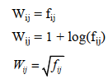

If the number of times the keyword t appears in the document dj is greater, it means that the document dj depends more on the keyword ti, or in other words, the keyword ti carries more information in the document dj. For example, if many computer keywords appear in the text, it means that the text is mainly related to the field of information technology.

**Some methods of integrating chatbots**

*Integration using API*

An API is an abbreviation of Application Programming Interface. It is a set of subroutine definitions and communication protocols and tools for building software. In essence, it can be said that API is a software architecture style, which provides a framework to design software which is able to communicate across devices, platforms and other software.

There are many methodologies to implement API architecture. One of the majorly used and the current standard is the RESTful API structure. REST API is briefly explained as follows.

REST is an acronym for Representational State Transfer. It defines the constraints to be used to develop and design a Web service. It provides interoperability between computing devices.

REST API uses HTTP requests such as GET, PUT, POST, DELETE, TRACE, CONNECT, OPTIONS, PATCH, etc. To provide communication and manipulation of data which resides on the Web server. It ensures communication between the Web Server and Client.

Using RESTful API, it is possible to make a single chatbot instance up and running on multiple different websites.

A chatbot service can be made by conforming to RESTful architecture and that service can then be integrated into multiple websites where the respective service is required.

The overall structure of RESTful web service can be visualized as provided in the diagram below:

1. 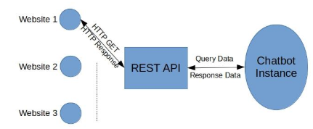

*Manual integration*

Usage of API is highly recommended if there are many instances of many websites. However, if the user has only a single website and does not want any fancy integration architecture, then manual integration of the chatbot would be the best option.

In this type of integration, chatbot logic, website logic as well as server side logic resides on the same server. Hence, this is the simplest kind of integration that a chatbot can have.

*Third-Party integration*

If API or manual integration is technically infeasible for the user then the user can opt for any third party chatbot providing service that also provides easy integration methods.

**CHAPTER 2: THEORETICAL FOUNDATION**

* 1. **Some general theories**
     1. **Overviews chatbots**

Chatbot is basically a software, application developed using a set of rules and artificial intelligence (AI) to simulate human conversations. It allows people to interact with digital devices as if they were communicating with real people. Chatbots also act as virtual assistants that can understand natural language and are responsible for interpreting and processing requests made by users, thereby giving them quick answers. , promptly at all times when customers have questions that need answering.

Chatbot is considered a smart tool thanks to its ability to receive information, analyze questions and respond exactly to what the user wants. Chatbots can be built as simple as rudimentary programs that answer a simple query with a one-line response or as complex as self-learning assistants that provide answers to complex questions. outside the data but repeated many times.

This is a product of modern technology, playing an important role in connecting people with automated software, with very high applicability, especially in the interaction between businesses and customers.

Chatbots have exploded in recent years. Chatbots contribute to automating the customer consulting process and allow the collection of necessary data, helping businesses better understand customers. AI Chatbot allows businesses to save costs in interacting with customers while enhancing user experience and interaction.

Chatbots contribute to automating the customer consulting process and allow the collection of necessary data, allowing businesses to better understand customers.

In the context of organizations and businesses increasing the trend of using Chatbots and more and more technologies supporting the development of this platform. According to Inside Intelligence, consumer retail spending through Chatbots will increase to $142 billion worldwide by 2024, compared to $2.8 billion spent in 2019.

Some of the industries that are adopting the use of chatbots include prominent sectors such as online retail, customer service, telecommunications, and banking. According to Juniper Research, it is estimated to save $7.3 billion in operating costs globally by 2023 in the banking industry alone through Chatbots. AI Chatbot is considered one of the most potential applications of artificial intelligence (AI) in commerce. Therefore, the need for research and development of AI Chatbot applications is increasing.

Integrating natural language processing capabilities helps chatbot applications become intelligent and provide more appropriate consulting support to users.

The basic structure of Chatbots includes 3 parts: database, application layer, API application programming interface.

The database will be exploited from available data for chatbots to serve the e-commerce system, filtering and training appropriate data.

There are 2 main types of Chatbots:

* Scripted Chatbots: These Chatbots often have behavior defined by rules. However, at each step in the conversation, users will need to select clear options to determine the next step in the conversation.
* Intelligent Chatbots: Intelligent Chatbots are Chatbots built with artificial intelligence techniques. Artificial intelligence allows them to improve more flexibly. Chatbots can take free-form input, which can be text, and unlimited other input if it makes sense.
  + 1. **Introducing artifical intelligence (AI)**

Artificial intelligence (AI) is a field of computer science that specializes in solving cognitive problems commonly associated with human intelligence, such as learning, creativity, and image recognition. Modern organizations collect a wealth of data from a variety of sources such as smart sensors, human-generated content, monitoring tools, and system logs. The goal of AI is to create self-learning systems that can figure out the meaning of data. AI then applies the acquired knowledge to solve new problems in the same way as humans. For example, AI technology can respond to a conversation with a human in a logical manner, generate original images and text, and make decisions based on real-time data input. Your organization can integrate AI features into your applications to optimize business processes, enhance customer experience, and accelerate innovation.

Each concept and definition of AI will give us different perspectives, but they all have their own correct perspectives, but in short, it can be simply understood that artificial intelligence is a branch of computer science. It builds on a solid theoretical foundation and can be applied to automating intelligent computer behavior. Help computers gain human intelligence such as: knowing how to think and reason to solve problems, knowing how to communicate by understanding language and speech, knowing how to self-study and self-adapt.

* + 1. **Chatbots system model**

NLP engine extracts users intent and entities from given phrase and sends back to chatbot.

Chat Client

Chatbot

Data Services

Natural Language Processing

Use types a pharse in the chat client.

Chatbot packages data into proper respone for display by the chat client.

Chatbot sends to the pharse to a machine learning NLP engine.

Intent is used to call upon proper service, using entity information to find proper data.

Data is returned to chatbot.

* 1. **Compare related research**

Chatbot technology is emerging as one of the hot topics in recent years. The technology has been developed since 1966 when Joseph Weizenbaum presented a chatbot named Eliza. Today, it is progressively becoming popular on social media and messaging applications. In April 2018, Facebook reported that 100,000 bots had been created on their Messenger platform, within only one year after its introduction (Johnson, 2017). Meanwhile, research firm Canalys predicted that 56.3 million smart speakers, a special type of chatbot using voice, will be sold in 2018, up from an estimated 33 million units shipped in 2017 and 6 million units shipped in 2016 (Canalys.com, 2018). Besides the rapid growth of messaging platforms such as Facebook Messenger or Slack and voice services like Amazon Alexa or Apple Siri, the recent advances in Artificial Intelligence (AI) with new techniques such as machine learning or deep learning also helped dramatically improve the quality of chatbot on parsing human language, understanding contexts, composing replies or making decisions. Currently, chatbot is mainly used for two purposes, answering inquiries from users and executing more complex transactions like ticket booking.

The rise of chatbot is catching attention from many companies, especially in the customer service context (e.g. Cui et al., 2017; McGrath, 2018; Peterson, 2017; Chung et al., 2018; Flaiz, 2018). According to Gartner (2018), more than half of companies have already invested in chatbot and by 2020, chatbot will power 25% of all customer service operation. In a survey conducted by Oracle of 800 senior marketers and sales professionals across Europe, the Middle East and Africa, 80 percent of brands said they already used chatbot or planned to use it to serve customers by 2020 (Brynjolfsson and Mcafee, 2017).

* 1. **Overview of dialogflow**

A Dialogflow agent is a virtual agent that handles concurrent conversations with your end-users. It is a natural language understanding module that understands the nuances of human language. Dialogflow translates end-user text during a conversation to structured data that your apps and services can understand. You design and build a Dialogflow agent to handle the types of conversations required for your system.

A Dialogflow agent is similar to a human call center agent. You train them both to handle expected conversation scenarios, and your training does not need to be overly explicit.

Agents also serve as a top-level container for settings and data:

* Agent settings for language options, machine learning settings, and other settings that control the behavior of your agent.
* Intents to categorize end-user intentions for each conversation turn.
* Entities to identify and extract specific data from end-user expressions.
* Knowledge to parse documents (for example, FAQs) and find automated responses.
* Integrations for applications that run on devices or services that directly handle end-user interactions for you (for example, Google Assistant).
* Fulfillment to connect your service when using integrations.
  1. **Overview of intent**

An intent categorizes an end-user's intention for one conversation turn. For each agent, you define many intents, where your combined intents can handle a complete conversation. When an end-user writes something, referred to as an end-user expression, Dialogflow matches the end-user expression to the best intent in your agent. Matching an intent is also known as intent classification.

For example, you could create a weather agent that recognizes and responds to end-user questions about the weather. You would likely define an intent for questions about the weather forecast. If an end-user says "What's the forecast?", Dialogflow would match that end-user expression to the forecast intent. You can also define your intent to extract useful information from the end-user expression, like a time or location for the desired weather forecast. This extracted data is important for your system to perform a weather query for the end-user.

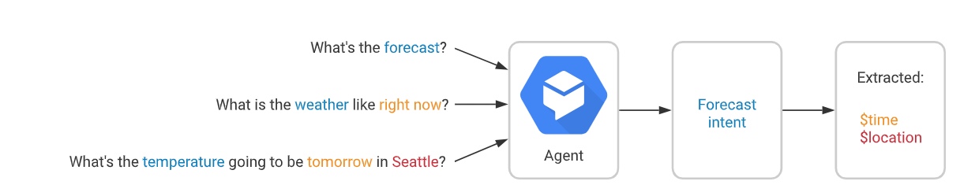

A basic intent contains the following:

* Training phrases: These are example phrases for what end-users might say. When an end-user expression resembles one of these phrases, Dialogflow matches the intent. You don't have to define every possible example, because Dialogflow's built-in machine learning expands on your list with other, similar phrases.
* Action: You can define an action for each intent. When an intent is matched, Dialogflow provides the action to your system, and you can use the action to trigger certain actions defined in your system.
* Parameters: When an intent is matched at runtime, Dialogflow provides the extracted values from the end-user expression as parameters. Each parameter has a type, called the entity type, which dictates exactly how the data is extracted. Unlike raw end-user input, parameters are structured data that can easily be used to perform some logic or generate responses.
* Responses: You define text responses to return to the end-user. These may provide the end-user with answers, ask the end-user for more information, or terminate the conversation.

The following diagram shows the basic flow for intent matching and responding to the end-user:

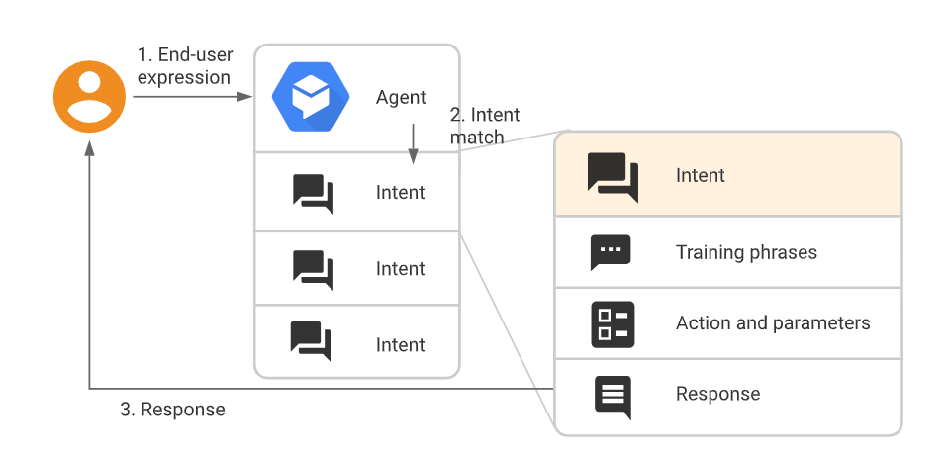

A more complex intent may also contain the following:

* Contexts: Dialogflow contexts are similar to natural language context. If a person says to you "they are orange", you need context in order to understand what the person is referring to. Similarly, for Dialogflow to handle an end-user expression like that, it needs to be provided with context in order to correctly match an intent.
* Events: With events, you can invoke an intent based on something that has happened, instead of what an end-user communicates.
  1. **Overview of contexts**

Dialogflow contexts are similar to natural language context. If a person says to you "they are orange", you need context in order to understand what "they" is referring to. Similarly, for Dialogflow to handle an end-user expression like that, it needs to be provided with context in order to correctly match an intent.

Using contexts, you can control the flow of a conversation. You can configure contexts for an intent by setting input and output contexts, which are identified by string names. When an intent is matched, any configured output contexts for that intent become active. While any contexts are active, Dialogflow is more likely to match intents that are configured with input contexts that correspond to the currently active contexts.